

Nicole Morton-Holmes
nicole@nicolemhconsulting.com ▪ 602.402.9856 ▪ LinkedIn
Chief Merchandising Officer  Board-Level Candidate  Strategic Consultant
Catalyst of Hyper Growth, Market Entry, and Profit Margin
Deep Expertise in the Pet Industry—Trends, Opportunities, Connections, Consumer Insights

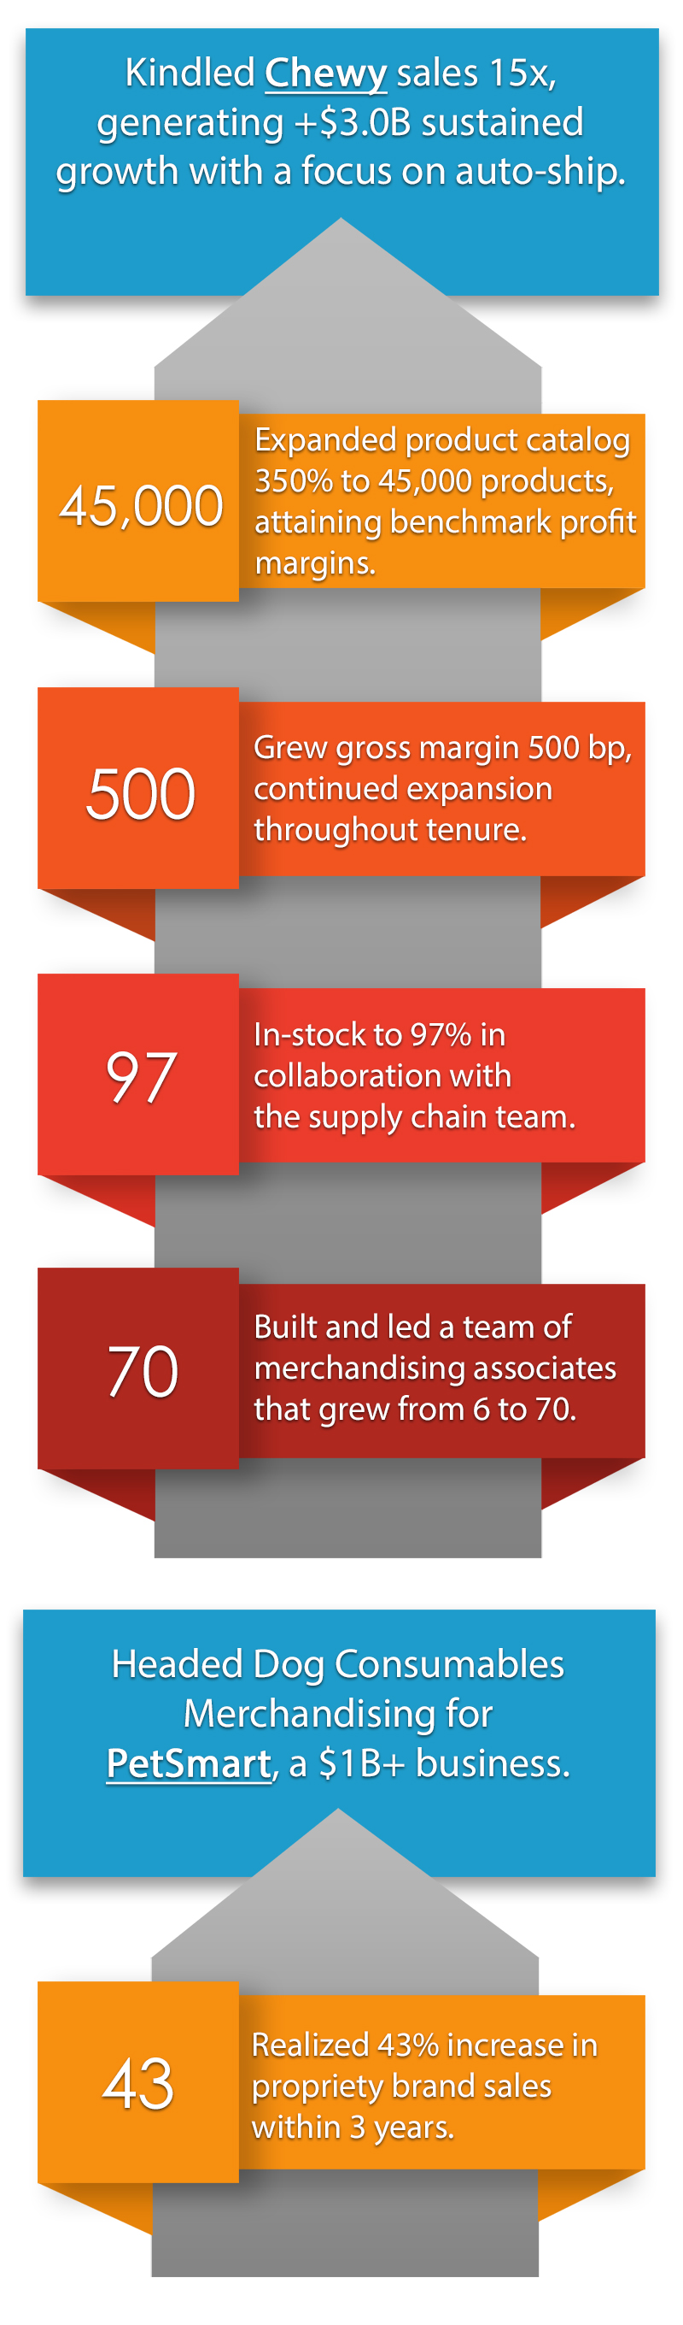

Steered Merchandising in the Largest E-commerce Acquisition in USA History to Date

Nicole Morton-Holmes is a take-charge, strategic, and highly experienced e-commerce/merchandising expert, a steward of growth who offers the differentiating value of a 22-year career in the pet industry. Nicole has championed ROI and captured groundbreaking growth in a highly saturated market for online retailer, Chewy and industry giants such as PetSmart—both have undergone a transformational journey with Nicole as the escort.

“I am persistent; I never quit. In the era of Amazon as on online force, we’ve been able to scale and win big.” ~ Nicole

Nicole is a visionary, tactical and deliberate executioner of best-in-class merchandising, including category management and operations. She is also a relatable mentor, trusted advisor to business owners/stakeholders, and an advocate of superior customer service. Her distinct blend of innovative product positioning, sales & marketing, and communications strategy evolve startups, early-stage, and established companies into industry frontrunners. Nicole navigates business ownership and sales/revenue demands and goals via a compass of market intelligence, product merchandising, inventory management, purchasing, supply chain, and high-stakes negotiations—listening and absorbing all points of view. Going big and keeping the big picture top of mind.

Nicole’s resilient and inquisitive nature; and her reputation as a savvy business leader make her an influential force in the pet industry. Valuing consistency in superior professionalism in all relationships, Nicole is an engaging, charismatic, and approachable executive who inspires action through meaningful dialogue. Owing to her unique relationship-building skills, she has formed and cultivated advantageous relationships with major manufacturers, CPG companies, and family-owned suppliers in the pet space—key to unlocking growth opportunities and outpacing competitors.

As a C-level leader, she is solutions-focused, identifies and fixes market, operations, and client issues while others are mired in the weeds. Nicole is intuitive and tactical, responding to shifts in the market. Further, her customer-centricity and perspective spur agility in solving pain points.

Career Journey

Her most recent post was as Chief Merchandising Officer at Chewy, where she also served as Vice President of Merchandising, and Director of Merchandising during a high-impact 5-year tenure. She joined Chewy during a startup phase. Battling for market share in the competitive industry, Nicole launched a complete overhaul (establish a hi-performing merchandising team, structured operations, revamped vendor management, expanded product catalog, improving margins and DPO). She is now credited with its explosive growth to the largest pet specialty online retailer, with sales of more than $3M.

In an earlier role she served as Director of Merchandising at PetSmart—a 15-year tenure replete of benchmark milestones. A career backdrop adding hard-to-match value to her holistic perspective and experience in offline and online merchandising.

Education

Bachelor of Science in Business Administration—University of Pittsburgh, PA

